Lab 2
Ocean and Continents – Plate tectonics
- As I move backward in time by slowly moving the time gauge down, the continents were together during the Triassic period
- Moving all the way to the bottom
- The position of New York through the general areas
General Areas | Different Times | Above/below water
South Pole | Paleozoic | Below
Equator | Triassic | Above
North Pole | Neogene | Above

- The stages of the Willison Cycle that you see in the model for the Atlantic Ocean 400 million years ago
This was the mature stage of the Willison Cycle whereby the Atlantic Ocean was characterized by widening of its basin and a continuous development into an ocean that is flanked by continental shelves, followed by a constant production of new as well as hot oceanic crust across its ridge system.
- Earth’s CO2 levels after every 20 million years
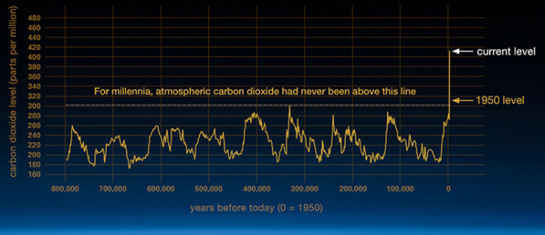
- How the ice sheet changes in North America and Europe and what happened to the ocean levels from 21,000 years ago
In this period, there were massive ice sheets covering Europe and North America. However, these large ice volumes lowered the earth’s sea level by -120 meters 21,000 million years ago. Since that period, however, the global sea level had been rising as it is shown after every 1000 years until today whereby the global sea level is at 80 meters.
- CO2 Levels for 21,000 years ago
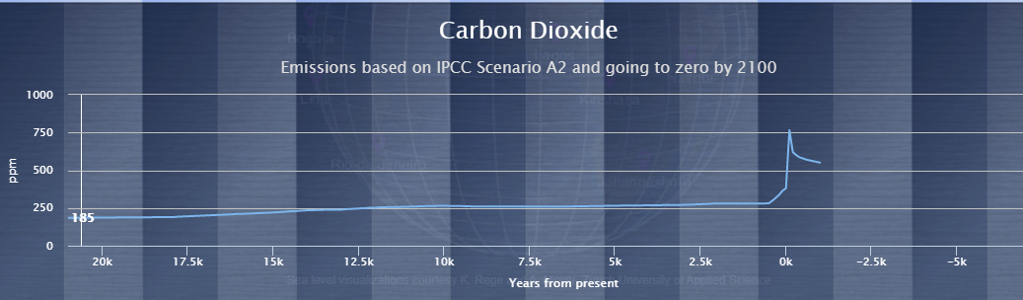

- Why the CO2 level goes above zero from 21,000 years ago to present
CO2 levels had been primarily increasing because of human activities and this means that the north pole had been experiencing more CO2 levels compared to the south pole because the south pole is a remote area and it is not highly impacted by the increasing emissions from the consumption of fossil fuels, which is the main driver of the greenhouse gas emission.
- The size of Florida 21,000 years ago.
From the look of things, Florida started forming from a combined volcanic activity as well as the marine sediments’ deposit along Northwest Africa about 21,000 million years ago. In such times, Miami was part of the Gondwanaland: the super continent that would later divide Africa and South America. Eventually, Florida was seen wedged between North America and Gondwanaland as they combined to create Pangea the super continent. As a result, Pangea broke up and left Florida in North America, whereby it slowly slipped through the waves and became part of North America’s continental shelf.
- Location Chart
Location | Name | Reason | Sediment
Pacific Ocean | Mendocino Ridge | Clay r volcanic component carried from land by wind to the ocean | Pelagic
Pacific Ocean | Lamont Seamounts | Active volcanism | Pelagic
Pacific Ocean | Wini Seamount near Hawaii | Active volcanism after fresh rocks collected during an expedition before an earthquake swarm | Pelagic

